New Press
Information

March 7th 2019
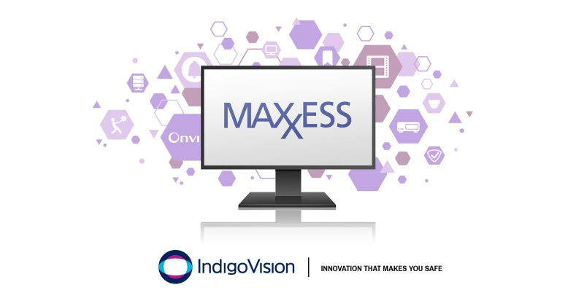

IndigoVision releases new version of the Maxxess Integration
IndigoVision, leading developer of complete end-to-end security surveillance solutions are excited to introduce a new version of the Maxxess Integration 2.0. This new version has been refreshed and expanded since its initial release 10 years ago.
The new version allows alarms and events from Maxxess systems to be seamlessly combined with IndigoVision’s security management solution, Control Center, giving complete video and alarm management in a single user interface.
All of IndigoVision’s Integrations are designed with your safety in mind and the new version of Maxxess Integration is no exception.
You can trigger live video, move PTZ cameras, start recordings and send notification emails automatically which helps to dramatically decrease operator response time.
It is now possible to energize and de-energize outputs and output groups as well as unlock or lock down doors or door groups in a Maxxess system directly from Control Center, by enabling relay actions.
By enabling alarm actions, Control Center operators acknowledging or clearing a zone alarm in Control Center will acknowledge or delete the corresponding alarms in the Maxxess system. The Maxxess Integration enables operators to respond to incidents from the familiar Control Center user interface.
Commenting on the Maxxess Integration, IndigoVision’s Software Product Manager, Giles Raine, said “We have a dedicated Integrations team who are continuously updating our integrations to support the latest versions and add more functionality. In this case we have done both – rewriting the integration to bring it in line with our software-licensed integration architecture, and adding the ability to lock and unlock doors from our Control Center user interface.”
The new Maxxess Integration adds to the existing IndigoVision portfolio, which gives you the flexibility and choice to create a custom security management solution that works for you. When you use any one of IndigoVision’s Integrations you can be sure that you won’t be let down.
To find out more about this release and the rest of IndigoVision’s innovative complete end-to-end security solution please visit www.indigovision.com.
END
About IndigoVision
IndigoVision has more than two decades of experience developing innovative, complete, end-to-end security surveillance solutions. We provide a complete video security solution where performance and stability go hand-in-hand. All of our products are single-mindedly designed towards enhancing your security and are trusted and proven globally, across multiple markets, in some of the highest profile sites and harshest environments.
Our unique Distributed Network Architecture (DNA) removes the need for a central server, resulting in no single point of failure You can add any number of cameras and workstations effortlessly. We make it smart, so your old analogue cameras will migrate to IP and work with our HD cameras.
Founded in 1994 Edinburgh, Scotland, upholding a truly global presence, our global technical support teams make your problem OUR problem. IndigoVision give you the right solution, experience, technology and support to provide you with the innovation that makes you safe.

