New Press
Information

April 8th 2019

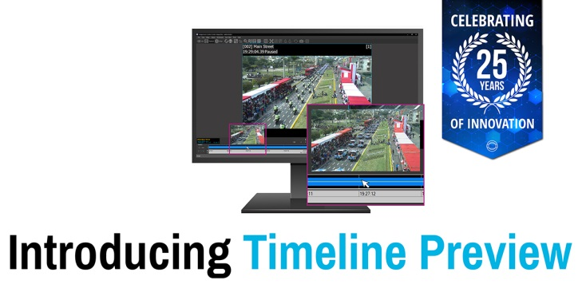

Photo Caption: Faster security investigations unveiled as part of IndigoVision’s new product innovations at America’s largest security event

Faster security investigations unveiled as part of IndigoVision’s new product innovations at America’s largest security event

Security innovator IndigoVision is set to introduce a range of new features that will lead to faster security investigations and drive down industry storage costs as part of its presence at ISC West 2019 in Las Vegas.

Trusted in installations across the world, and with 25 years of experience in developing complete end-to-end security surveillance solutions, IndigoVision’s latest innovations will be unveiled as part of an array of new features being introduced to Control Center, its intuitive Security Management Solution.

Focusing on advanced analytics, cyber-security and ease of use, Control Center v16.0 will offer operators a powerful new line-up of features to help combat security threats.

- Faster security investigations – users will be able to save time and instantly zero in on specific events with the introduction of timeline preview, which provides a thumbnail of the recorded video timeline.

- Lower storage costs – users will benefit from improved compression and longer retention times thanks to Control Center’s support for the latest video compression standard, H.265.
- Reduced eyestrain for users – Control Center v16.0 now adds to its core grey/white view with a new Dark Mode, which has been specifically designed to reduce eyestrain in darker control room environments.

Appearing at booth 23031 from 10th to the 12th April, IndigoVision will add to its Ultra and BX camera ranges with the introduction of an exciting new line-up which offers users multiple form factors, low light sensitivity, augmented analytics and wide dynamic range (WDR) giving operators improved image clarity.

The new HD Ultra X Cameras will deliver enhanced performance through the company’s ground breaking SMART.core™ and CyberVigilant® in-camera technology which give users the ability to detect and respond quickly to potential cyber-threats. NDAA compliance also means these cameras are pre-approved for installation in government sites within the United States and other areas of the world where this legislation has been adopted.

Operators will also be able to access next level detection and cyber-security with IndigoVision further expanding its advanced Analytics Metadata and its award-winning CyberVigilant® technology to select cameras from its BX Camera range. The BX420 4K Minidome, BX430 4MP Microdome and BX630 HD/4K Bullet and Fixed Cameras will now have an enhanced intruder detection enabling Control Center to safeguard against an increased range of threats.

For more information about this launch and the rest of our end-to-end security solution please visit www.indigovision.com or find us on social media @IndigoVisionLtd.

ENDS

Technical notes

SMART.core™
IndigoVision’s improved SMART.core™ technology gives you better audio, lower bandwidth and storage requirements, intelligent analytics and better low light and PTZ control performance.

CyberVigilant® in Camera
CyberVigilant® in Camera offers a quick response to potential cyber-threats. CyberVigilant® in Camera provides enhancements to your existing camera firewall by detecting unauthorized access as it is attempted.

About IndigoVision

IndigoVision has more than two decades of experience developing innovative, complete, end-to-end security surveillance solutions. We provide a complete video security solution where performance and stability go hand-in-hand. All of our products are single-mindedly designed towards enhancing your security and are trusted and proven globally, across multiple markets, in some of the highest profile sites and harshest environments.

Our industry leading Distributed Network Architecture (DNA) removes the need for a central server, resulting in no single point of failure. You can add any number of cameras and workstations effortlessly. We make it smart, so your old analogue cameras will migrate to IP and work with our HD cameras.

Founded in 1994 Edinburgh, Scotland, upholding a truly global presence, our global technical support teams make your problem OUR problem. IndigoVision give you the right solution, experience, technology and support to provide you with the innovation that makes you safe.

