New Press
Information
May 17th, 2018

April 12th, 2018
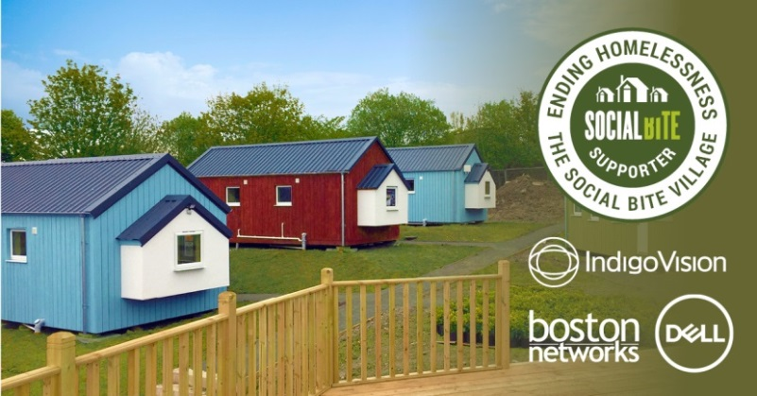

New Press
Information
May 17th, 2018

April 12th, 2018

New Press
Information
May 17th, 2018

April 12th, 2018
IndigoVision, Boston Networks and Dell Technologies team up with Social Bite to tackle homelessness in Scotland
Developer of complete end-to-end video security solutions, IndigoVision, along with their Authorized Partner Boston Networks and valued Technology Partner Dell Technologies, has provided Social Bite with a security system for their Social Bite Village.
Social Bite is on a mission to build a collaborative movement to end homelessness in Scotland, thanks to recent fundraising efforts the Social Bite Village has become one of their many projects to help achieve this goal. The idea is to bring people from all walks of life in Scotland together to ensure that no one ends up homeless.
The Social Bite Village aims to provide a low cost, innovative and safe environment for up to 20 people for 12-18 months. Residents will be provided with the support, community and skills required to get their life back on track, including work placement opportunities and employability support. After the 12-18 months, the residents will transition to permanent accommodation and receive support in gaining employment, supporting their return to society. As one group of residents leaves the village, another can then enter and begin their journey. Residents will be selected from individuals in temporary and unsupported accommodation. The ambition behind this project is to create a full circle solution to the issue of homelessness – from housing to support to employment.
IndigoVision, Boston Networks and Dell Technologies have worked together to help Social Bite reach their goal by installing a security system to provide surveillance for the village site, specifically during the evening hours to ensure all people on site were kept safe.
Commenting on our involvement with this project IndigoVision’s Chief Executive Officer, Pedro Simoes, said “IndigoVision is proud to have been a part of a project that will contribute with such a positive change in Scotland. It’s been a great privilege to work along with Boston Networks and Dell Technologies to provide the Social Bite Village with innovation that makes you safe.”
As part of the installation IndigoVision provided 11 state of the art BX HD Vandal Resistant Minidome Cameras, which deliver high quality video and audio in all environmental conditions.
Boston Networks provided a survey of the Granton Road site, following which they laid cabling and set up point-to-point links to provide backhaul connectivity to support the network, before installing the cameras and configuring the security system. Purdicom and InfiNet, Boston Networks’s distribution and wireless partners, provided the back-to-back wireless kit and license.
Finally a Hybrid NVR Workstation, which allows Social Bite to save recordings from the site, and a Workstation Monitor have been provided by Dell Technologies to complete the security system.
Founder of Social Bite, Josh Littlejohn MBE, said: "Companies such as IndigoVision, Boston Networks and Dell Technologies have gone above and beyond in supporting Social Bite to create the Social Bite Village in Granton, Edinburgh. We are deeply thankful - your contribution will help ensure that we are able to support people towards independence, changing lives for the better."
The official opening of the Social Bite Village took place today, Thursday 17th May.
For more information about IndigoVision and their security solutions please visit: www.indigovision.com/
To find out more information about the Social Bite Village please visit: www.social-bite.co.uk/the-social-bite-village/
END
About IndigoVision
IndigoVision provides a complete video security solution where performance and stability go hand-in-hand. All of our products are single-mindedly designed towards enhancing your security. The purpose of a security system is to make you safe and feel safe. That includes your person, business, property and budget. We design your system end-to-end, with no single point of failure, so it's reliable. We design it with Distributed Network Architecture so it's flexible. You can add any number of cameras and workstations effortlessly. We make it smart, so your old analogue cameras will migrate to IP and work with our HD cameras. You can integrate other HD cameras where and when you need them or other manufacturers' security systems using our Software Development Kit, such as Access Control, Communication Systems and Perimeter Detection. When you choose an IndigoVision system you are future-proofed: the cameras you buy today we will still support for years to come. Our global support team backs it all up so your problem is our problem. IndigoVision give you the right solution, experience, technology and support to provide you with the innovation that makes you safe.

